# Utilisation du capteur de température DS18B20

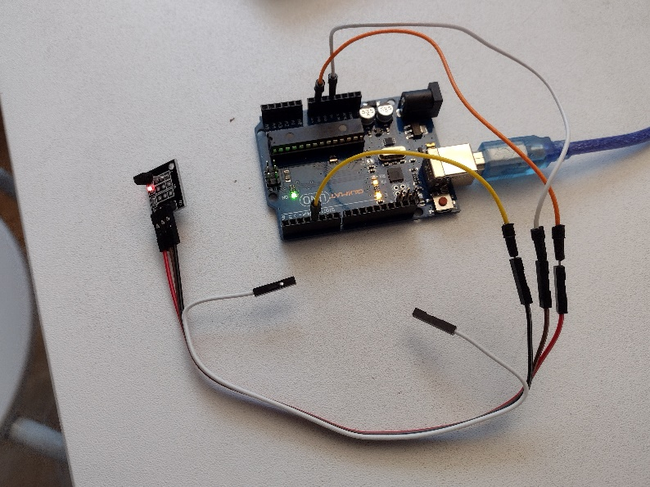 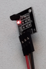

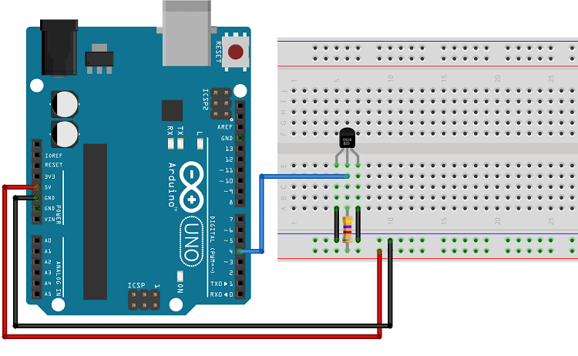

/*********

Rui Santos

Complete project details at https://randomnerdtutorials.com

Based on the Dallas Temperature Library example

*********/

#include <OneWire.h>

#include <DallasTemperature.h>

// Data wire is conntec to the Arduino digital pin 4

#define ONE_WIRE_BUS 4

// Setup a oneWire instance to communicate with any OneWire devices

OneWire oneWire(ONE_WIRE_BUS);

// Pass our oneWire reference to Dallas Temperature sensor

DallasTemperature sensors(&oneWire);

void setup(void)

{

// Start serial communication for debugging purposes

Serial.begin(38400);

// Start up the library

sensors.begin();

}

void loop(void){

// Call sensors.requestTemperatures() to issue a global temperature and Requests to all devices on the bus

sensors.requestTemperatures();

// Serial.print("Celsius temperature: ");

// Why "byIndex"? You can have more than one IC on the same bus. 0 refers to the first IC on the wire

Serial.println(sensors.getTempCByIndex(0));

// Serial.print(" - Fahrenheit temperature: ");

// Serial.println(sensors.getTempFByIndex(0));

delay(100);

}